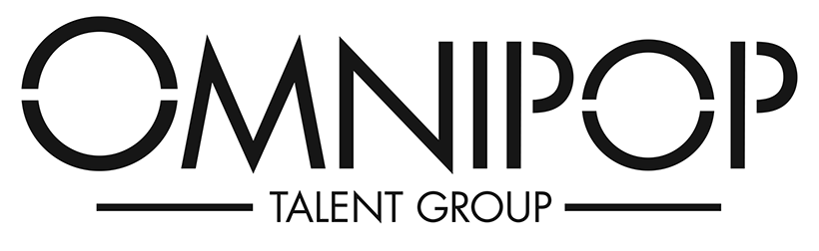

ERICA BECK

“Aw! You guys made me ink!” – that’s her! Erica Beck voiced Pearl the Octopus in Finding Nemo, but she’s actually a real human girl who grew up in LA and has been in NYC for
the past 10 years.
Most recently Erica has been making waves in the VO world (alright we’ll stop with the ocean references), you can hear her in ads from Clorox, Pepsi, State Farm x ADT, as well as games like Paragon and Cookie Run Kingdom. Past on-camera work includes guest roles on Nickelodeon, iCarly (Dippity Do!) and Unfabulous (getting pizza rolls thrown at her) or being quite the annoying girl scout on ER.
She attends weekly scene study classes under the Stuart Rogers Studio and has a strong foundation in acting (BFA Musical Theatre), comedy (UCB and Magnet improv training) and voice (Mezzo Soprano Belt).

